Paint Assignment OOP

Names :

* Karim Atef Ahmed Mohamed (31)
* Abdallah Mohamed Fawzy ElSaman (25)

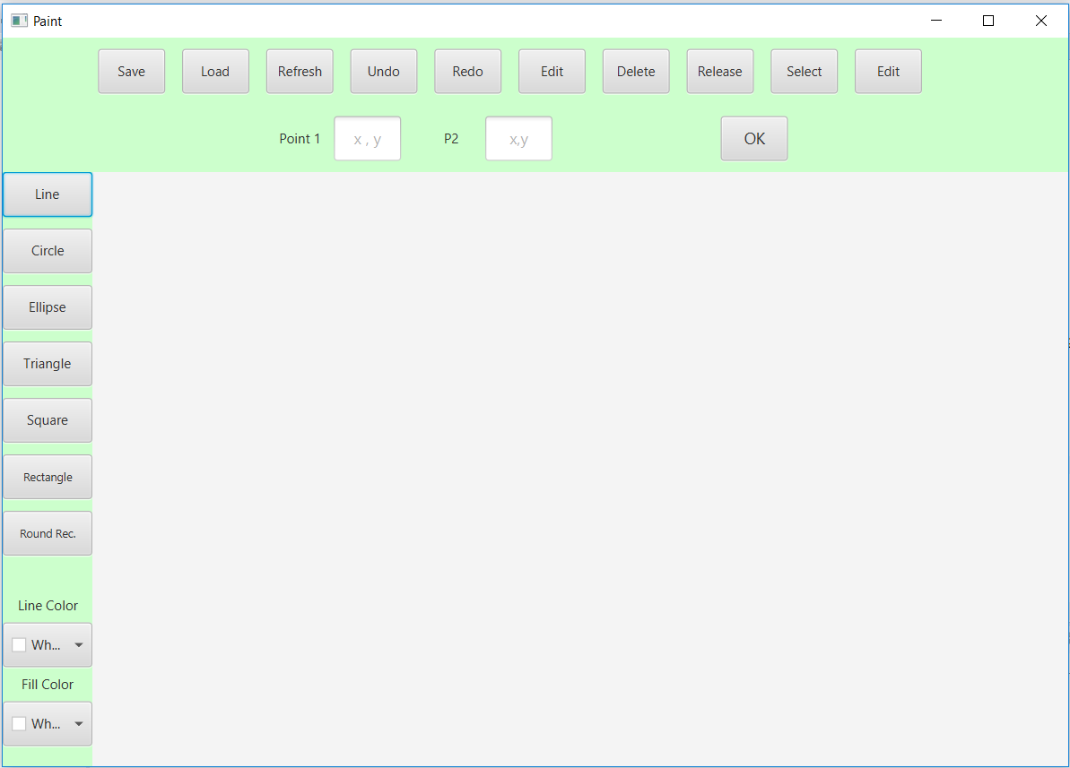

**Overview :**

Drawing​ ​and​ ​painting​ ​applications​ ​are​ ​very​ ​popular​ ​and​ ​have​ ​a​ ​huge​ ​user​ ​base, they​ ​generally​ ​offer​ ​a​ ​big​ ​number​ ​of​ ​features​ ​that​ ​includes​ ​but​ ​is​ ​not​ ​limited​ ​to: Drawing,​ ​Coloring,​ ​and​ ​Resizing.​ ​They​ ​also​ ​include​ ​several​ ​built​ ​in,​ ​and​ ​possibly extensible​ ​set​ ​of​ ​geometric​ ​shapes,​ ​and​ ​classically,​ ​they​ ​allow​ ​the​ ​user​ ​to​ ​undo​ ​or redo​ ​any​ ​instructions​ ​to​ ​make​ ​the​ ​application​ ​more​ ​usable.

**UML Class Diagram :**

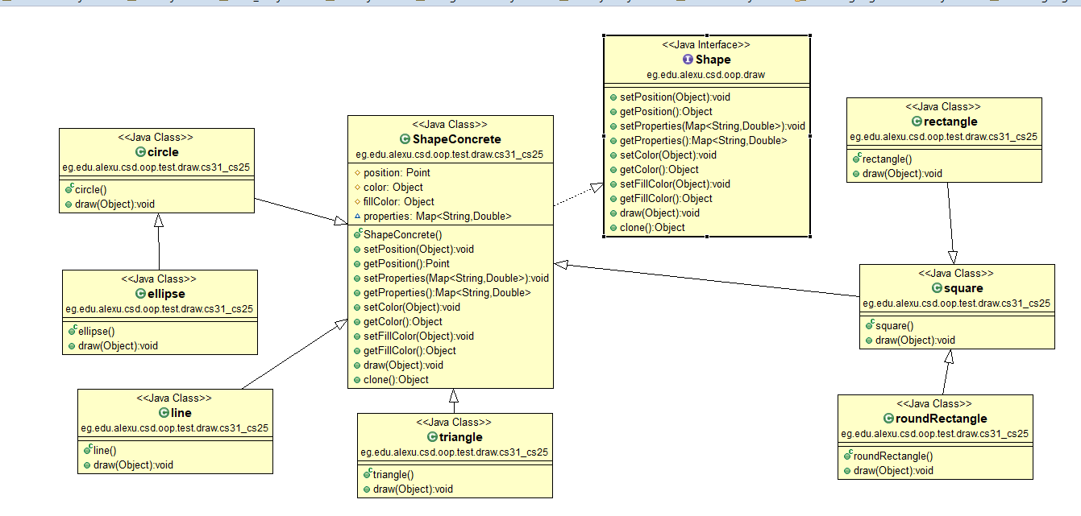

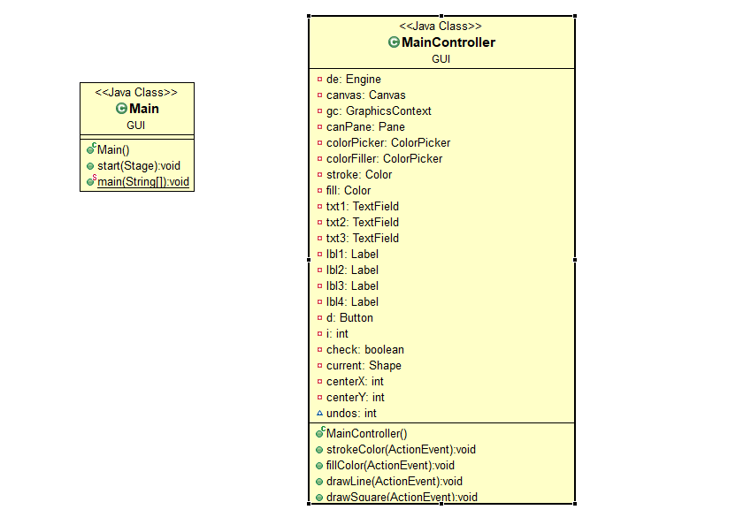

**Design Description:**

* Position methods that set and get the position of the shape
* Properties methods that set and get the properties of the shape and save it in a map
* Color methods that set and get the colors of the shape and the fill color of it
* Draw method that draws the shape on the given canvas
* Clone method that creates a clone of the shape
* DrawingEngine :

1. Refresh method that loops through all elements and draw all shapes
2. AddShape method that adds a new shape given from the gui and add it in the history list
3. UpdateShape method that update the selected shape with a new shape
4. Undo method that undo the last 20 actions
5. Redo method that redo the undo actions
6. GetShapes method that return all the shapes from the list
7. GetSupportedShapes method that adds all classes which can be drawn

**Sample Run & User Guide:**

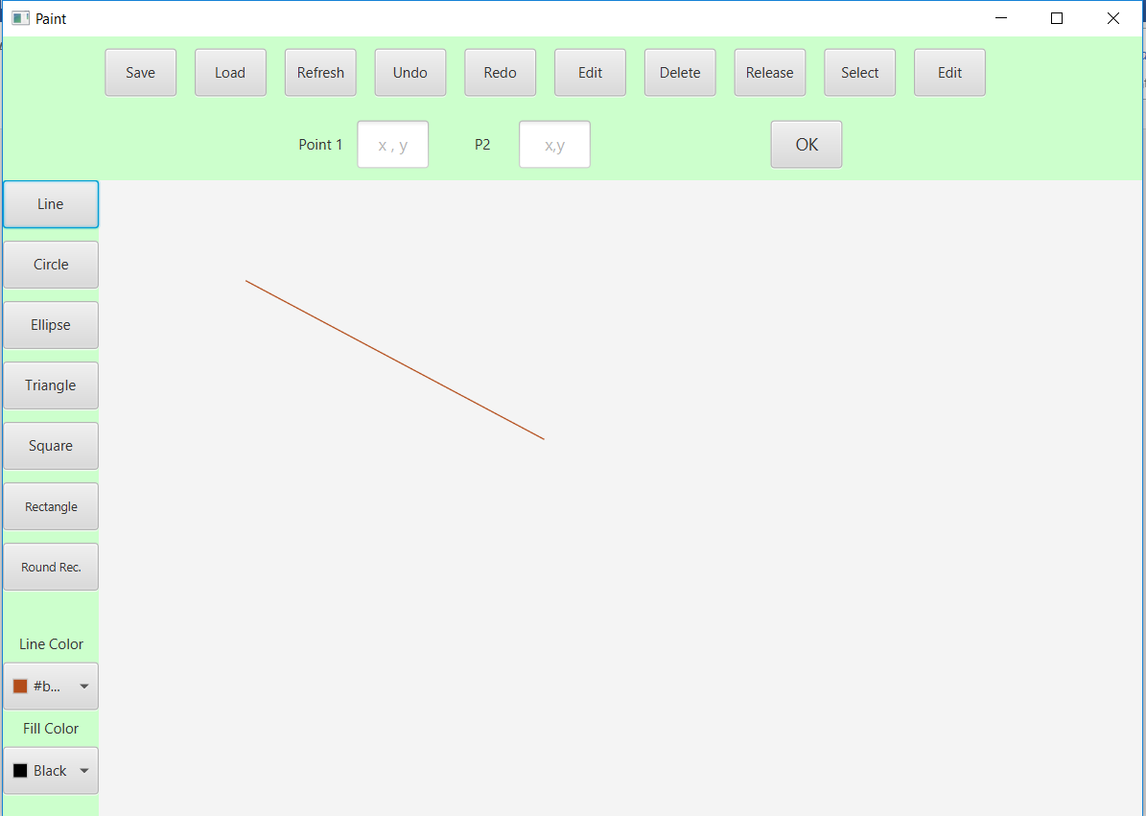

In each shape selected from the left buttons , required properties such as first point , last point, length , and width … appeared for the user to enter them in text fields as shown in figure 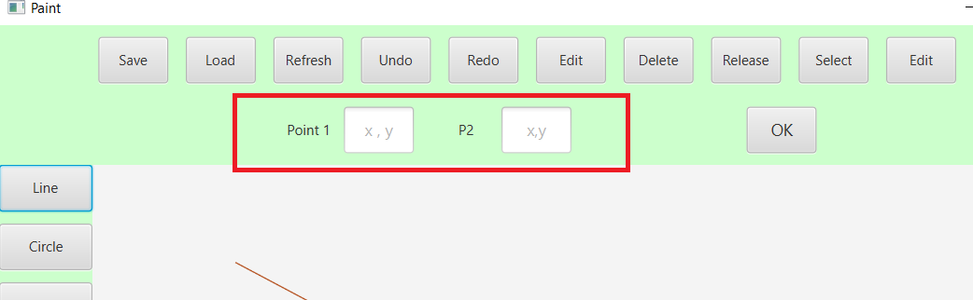

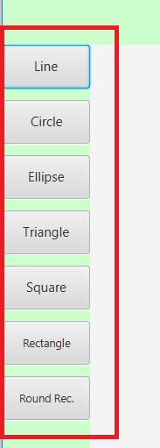

Each shape has its own properties and the user can choose the wanted shape from these buttons as shown.

After the user enters the required and press OK button the shape will be drawn

Or the user can just drag the mouse from one point on the canvas to another point to draw a line as example.

the user can choose the stroke color and the fill color from the color pickers found on left bottom:

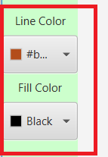

Some examples of the shapes:

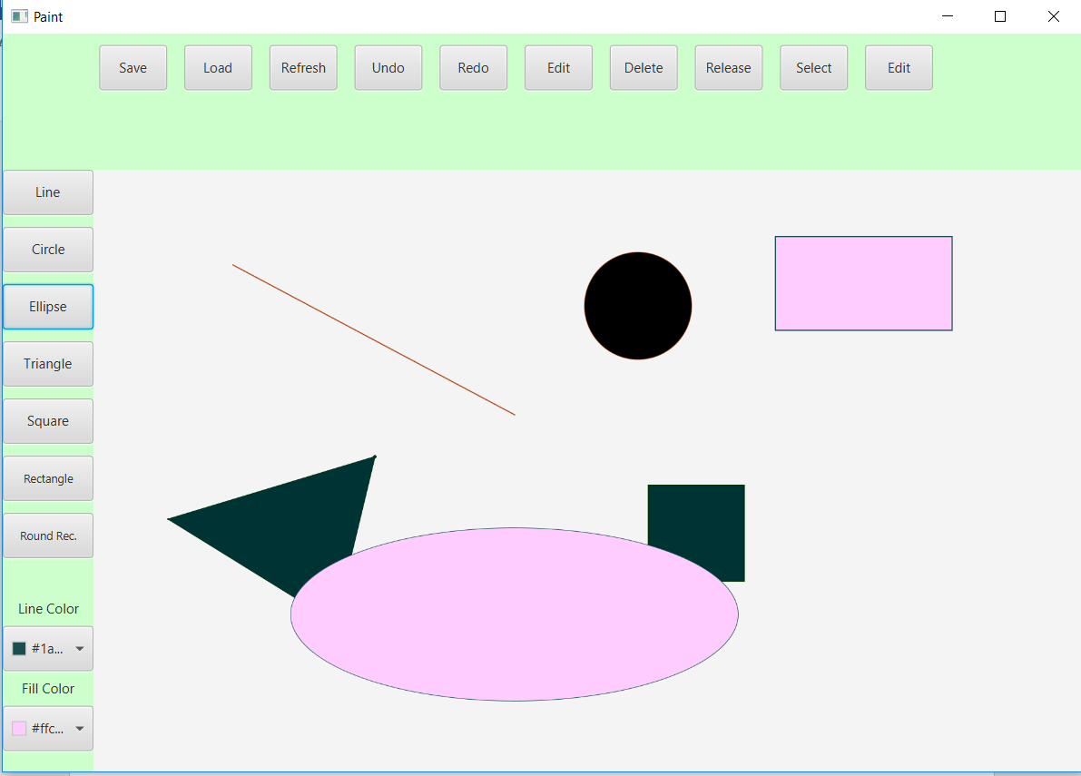

The triangle shape can be drawn by entering the 3 points in the text fields that will appear when the user chooses triangle, or can just click the mouse for the 3 points on the canvas to draw the triangle.

Else every shape can be drawn by dragging the mouse from the first point to the last point of the shape as in square rectangle or by dragging the mouse from the center to the required radius as in the circle and the ellipse.

The user can select from the drawn shapes using select button and then click on the required shape.

Then with the selected shape the user can remove it using delete button or can edit its properties or update it using select then edit button, the properties will appear again to the user in the text fields then he can edit them and press the OK button and the shape will be updated.

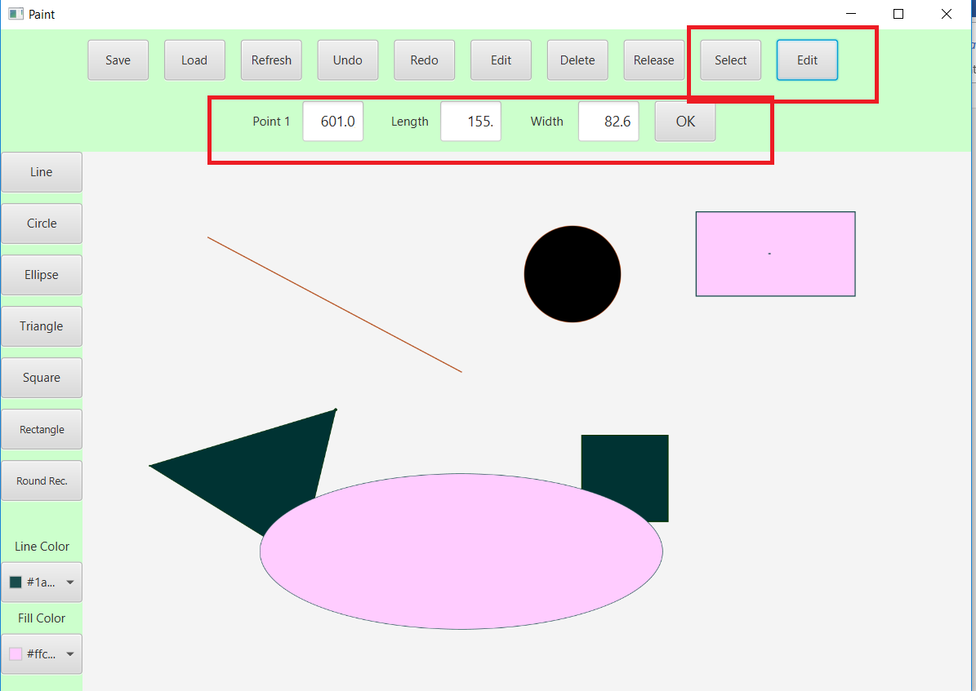

In The previous example the user selected the rectangle shape and pressed edit then the properties of the rectangle appeared to him, he can then change it and when press OK button the shape will be updated with its new properties.